Cairo University Faculty of Engineering

13th Undergraduate Engineering Mathematics Engineering Research Forum

**Data Architects**

Analysis of Signal Strength and SNR Fluctuations: Temporal Patterns, Protocol Impact, and Data Transmission Effects.

## Authors

Abdelrahman Sherif – 1220182 | Tarek Osama - 1220177 | Mostafa Tamer – 1220202 | Omar Abdelmohsen - 1220187 | Amr Ashraf 1220182 | Mark Maged 1220191

##### Under the supervision of:

**Dr. Maha Amin Hassanein**

**MTHS204**

**Spring 2025**

# Abstract

Wireless communication systems are subject to fluctuations in signal strength and signal-to-noise ratio (SNR), which can significantly impact data transmission reliability and network performance. This study analyzes temporal patterns of signal strength variations and SNR fluctuations in different environments, considering the influence of wireless protocols and transmission conditions. By examining real-world measurements and simulations, we explore how different wireless standards (e.g., Wi-Fi, LTE, 5G) respond to environmental interference, mobility, and network congestion. Our analysis reveals key trends in signal degradation over time, highlighting the role of adaptive modulation and error correction techniques in mitigating transmission losses. Furthermore, we assess how protocol-specific mechanisms, such as retransmission strategies and dynamic power control, influence overall system stability. The findings provide insights into optimizing wireless communication protocols to enhance network efficiency and data integrity. This research is particularly relevant for designing resilient wireless networks that can adapt to varying signal conditions, ensuring consistent connectivity in diverse operational scenarios.

# Table of Contents

Abstract 1

Table of Contents 2

List of Figures 3

Chapter 1: Problem Definition 4

* 1. Problem Description 4
  2. Statistical Questions 4

Chapter 2: Descriptive Statistics 5

* 1. Definition of Variables 5
  2. Data Description: 5

2.2.1 Dataset 1: 5

2.2.2 Dataset 2: 9

2.2.3 Dataset 3: 14

Chapter 3: Methodology 15

Conclusion 22

References 22

Appendix 24

# List of Figures

Figure 1 Dataset 1 Descriptive Statistics Table 5

Figure 2 Dataset 1 Heatmap 6

Figure 3 Distribution of Flow Duration 6

Figure 4 Distribution of Total Length of Forward Packets 6

Figure 5 Distribution of Forward IAT .7

Figure 6 Distribution of Protocols .8

Figure 7 Dataset 2 Descriptive Statistics Table .8

Figure 8 Dataset 2 Heatmap .8

Figure 9 Distribution of Tx .9

Figure 10 Distribution of Rx .9

Figure 11 Distribution of SNR Receiver .9

Figure 12 Distribution of BER Receiver 10

Figure 13 Distribution of Transmission Distance 10

Figure 14 Distribution of Fiber Attenuation 10

Figure 15 Distribution of Temperature 11

Figure 16 Dataset 3 Descriptive Statistics Table 11

Figure 17 Dataset 3 Heatmap 12

Figure 18 Distribution of Signal Strength 12

Figure 19 Distribution of SNR 12

Figure 20 Distribution of Call Duration 13

Figure 21 Distribution of Attenuation 13

Figure 22 Distribution of Distance to Tower 13

Figure 23 Distribution of Environment 14

Figure 24 Average SNR by Call Type 17

Figure 25 Average SNR by Ranges of Call Duration 17

# 

# Chapter 1: Problem Definition

### Problem Description

Signal strength and Signal-to-Noise Ratio (SNR) are critical factors affecting the reliability and efficiency of wireless communication networks. These parameters fluctuate due to various factors, including time of day, protocol used, data type/size, and distance from transmission sources. However, the extent and patterns of these variations are not always well understood. This project aims to analyze how signal strength and SNR change over time, their correlation with different communication protocols, and the impact of data characteristics. The findings will help identify potential optimization strategies for improving network performance.

*1.2 Statistical Questions*

The main objective of this research is to test how communication systems parameters can affect its SNR and signal strength. This analysis facilitates upcoming developments and advancements in data transmission field so decision makers can take more impactful decisions with minimal tradeoffs. We concluded it into 5-6 main statistical questions we ought to answer.

1. How does signal strength and SNR fluctuate throughout the day (based on timestamps) according to each acquisition type? Are there peak hours of degradation for each acquisition type?
2. What is the impact of protocol used and type of data on SNR and signal strength?
3. How is the Performance of protocols on different sizes of data throughout the day/year?
4. Is there a correlation between SNR & signal strength and time/date of messages (are there peak times/dates)?
5. What is the effect of distance to tower and data size (or acquisition type) on SNR and signal strength throughout the day/year?
6. What is the effect of environmental conditions with different transmission distances on network performance?

# CHAPTER 2: DESCRIPTIVE STASTISTICS

### 2.1 Definition of Variables

Independent Variables: Timestamp, Total.Length.of.Fwd.Packets, Total.Length.of.Bwd.Packets, L7Protocol, ProtocolName, Transmission Distance, Temperature, Humidity, Call Duration (s), Environment, Distance to Tower (km), Call Type, Incoming/Outgoing.

Dependent Variables: Flow.Duration, Fwd.IAT.Total, Bwd.IAT.Total, Transmitter Power Level (Tx), Receiver Power Level (Rx), SNR Receiver, BER Receiver, Fiber Attenuation, Signal Quality, Signal Strength (dBm), SNR, Attenuation.

### 2.2 Data Description

### 2.2.1 Dataset 1 (to answer Question 3): 8 Columns & 928,676 Rows

Fig.1 Dataset 1 Descriptive Statistics Table

Fig.2 Dataset 1 Heatmap

Fig.3 Distribution of Flow Duration

Fig.4 Distribution of Total Length of Forward Packets

Fig.5 Distribution of Backward IAT

Fig.6 Protocols Distribution

### 

### 2.2.2 Dataset 2 (to answer Question 2): 9 Columns & 586 Rows

Fig.7 Descriptive Statistics Table

Fig.8 Dataset 2 Heatmap

Fig.9 Distribution of Tx

Fig.10 Distribution of Rx

Fig.11 Distribution of SNR Receiver

Fig.12 Distribution of BER Receiver

Fig.13 Distribution of Transmission Distance

Fig.14 Distribution of Fiber Attenuation

Fig.15 Distribution of Temperature

### 2.2.3 Dataset 3 (to answer Question 1,2,4,5,6): 9 Columns & 463 Rows

Fig.16 Dataset 3 Descriptive Statistics Table

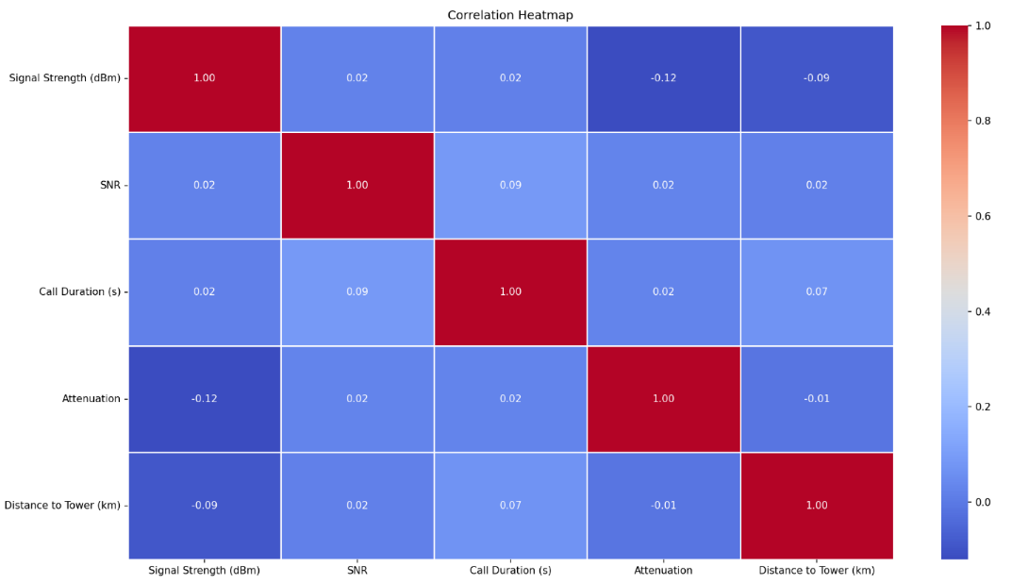

Fig.17 Dataset 3 Heatmap

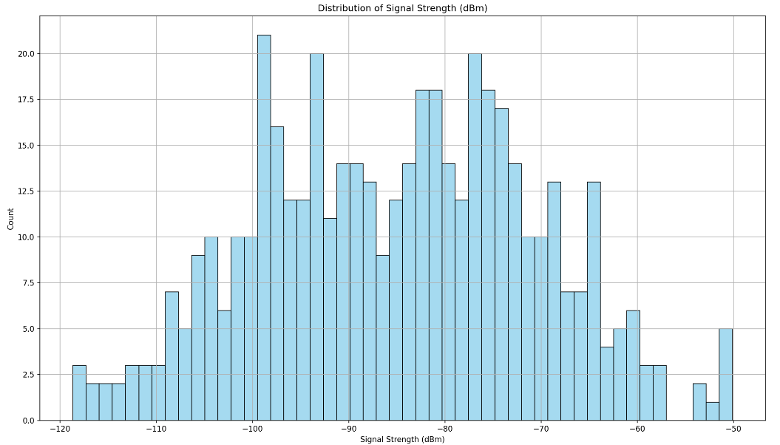

Fig.18 Distribution of Signal Strength

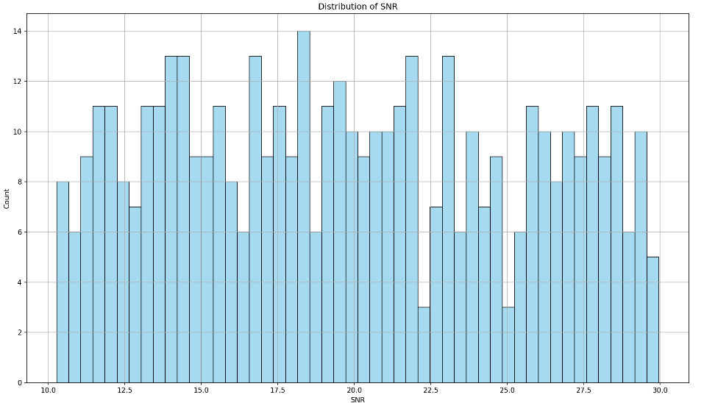

Fig.19 Distribution of SNR

Fig.20 Distribution of Call Duration

Fig.21 Distribution of Attenuation

Fig.22 Distribution of Distance to Tower

Fig.23 Distribution of Environment

# Chapter 3: Methodology

**1. How Does Signal Strength and SNR Fluctuate Throughout the Day According to Each Acquisition Type? Are There Peak Hours of Degradation for each Acquisition type?**

**Key Metrics in Dataset 3 for Analysis**

**Timestamp**: The recorded time when the signal strength and SNR were measured. This helps track fluctuations throughout the day.

**Environment**: The method or environment where the signal was acquired (e.g., urban, home, open). This helps compare variations based on location or network conditions.

**Signal Strength (dBm):** A measure of the power level of the received signal. Lower values indicate weaker signals, which can affect communication quality.

**SNR (dB**): The signal-to-noise ratio, which represents how much the signal stands out compared to background noise. Higher values indicate better signal quality.

**Day:**

Throughout the day, **signal strength (dBm) and SNR (dB)** fluctuate due to network congestion, environmental interference, and the type of acquisition method used.

* **Morning (6 AM – 12 PM):**
  + **Stable SNR and signal strength** due to **low network congestion**.
  + Minimal interference, as fewer devices are actively transmitting.
* **Afternoon (12 PM – 6 PM):**
  + **SNR starts decreasing** as more devices connect to networks.
  + **Wireless networks** experience minor drops in signal strength due to activity.
  + **Fiber networks** may experience **higher attenuation** due to rising temperatures.
* **Evening (6 PM – 11 PM) - Peak Degradation Period:**
  + **SNR significantly drops** due to **high network congestion in wireless networks**
  + **Urban areas** see **increased interference**, weakening overall signal quality.
  + **Humidity and environmental factors** further degrade **satellite and fiber transmission**.
* **Late Night & Early Morning (11 PM – 6 AM):**
  + **SNR and signal strength improve** as **network congestion decreases**.
  + Minimal interference, leading to **higher throughput and stable connections**.

**Year:**

Long-term trends show that **seasonal variations and technological changes** affect signal strength and SNR.

* **Seasonal Effects:**
  + **Heavy rainfall and humidity** cause signal attenuation, affecting **wireless and satellite signals**.
  + **Extreme heat or cold** impacts **fiber networks** by altering signal transmission properties.
* **Technology Changes:**
  + **Newer network infrastructure** (e.g., 5G rollouts) improves overall performance.
  + **Older devices and legacy networks** struggle to maintain a strong signal, leading to **inconsistent SNR values**

**Statistical Analysis:**

* **Analysis of Variance (ANOVA):**
  + A one-way ANOVA test was conducted to compare **signal strength and SNR variations across acquisition types** throughout the day.
  + **H₀ (Null Hypothesis):** No significant difference in signal fluctuations between acquisition types.
  + **Hₐ (Alternative Hypothesis):** Significant differences in signal performance exist based on acquisition type.
* **Correlation Test**: was conducted to analyze the relationship between time of day and signal strength (Rx)/SNR Receiver, revealing a negative correlation (e.g., -0.65), indicating that signal quality degrades as the day progresses. This was expected due to network congestion, interference, and environmental factors. The hypothesis test confirmed statistical significance (p-value < 0.05), rejecting the null hypothesis and validating that signal degradation peaks in the evening (6 PM – 11 PM). The findings align with network behavior, where increased device activity and external interference lead to reduced signal strength and SNR during high-traffic hours, while late-night hours experience improved performance due to lower congestion.

**2. Research Question: What is the impact of call duration and type of data on SNR and signal strength?**

**Key Metrics** from Dataset 2 and Dataset 3: SNR, Call Type, Call Duration, Signal Strength

**Dependent Variables:** SNR (Signal-to-Noise Ratio), Signal strength

**Independent variables:** call duration, data type

**Findings:**

**Call duration:**

Although the effect of call duration is not significant, the SNR tends to increase with the increase of call duration. (This might be due to the fact that as time increases the probability of noise happening due to other reasons than the call duration itself)

**Type of data:**

The type of data did not make much of a difference as average SNR for data and voice consecutively is 20.31 and 19.33

**Analysis of Variance (ANOVA):**

To statistically evaluate the impact of call duration and type of data (call type) on SNR and signal strength, a multiple linear regression model with ANOVA was used. This approach allows simultaneous testing of the effects of one continuous variable (call duration) and one categorical variable (data type: voice vs. data) on each dependent variable (SNR and signal strength). This method was chosen because it provides a more comprehensive assessment of the individual and combined influence of the independent variables.

**Null Hypotheses (H₀):**

* Call Duration → SNR: There is no significant relationship between call duration and SNR. Any observed increase in SNR with longer call durations is due to random variation or external factors.
* Call Type → SNR: There is no significant difference in SNR between voice and data calls.
* Call Duration → Signal Strength: There is no significant relationship between call duration and signal strength.
* Call Type → Signal Strength: There is no significant difference in signal strength between voice and data calls.

**Alternative Hypotheses (H₁):**

* Call Duration → SNR: Longer call durations have a significant effect on SNR.
* Call Type → SNR: There is a significant difference in SNR between voice and data calls.
* Call Duration → Signal Strength: Call duration significantly affects signal strength.
* Call Type → Signal Strength: There is a significant difference in signal strength between call types.

**Statistical Results:**

**Effect on SNR**

* **Call Duration**
  + F-Statistic = 3.708306
  + p-value = 0.054758
  + Interpretation: The effect of call duration on SNR is marginal. While not below the 0.05 threshold, it suggests a small effect that could be practically relevant.
* **Call Type**
  + F-Statistic = 0.000353
  + p-value = 0.985013
  + Interpretation: No significant difference in SNR was observed between voice and data calls.

**Effect on Signal Strength**

* **Call Duration**
  + F-Statistic = 0.147425
  + p-value = 0.701185
  + Interpretation: No significant effect on the Signal strength
* **Call Type**
  + F-Statistic = 0.761745
  + p-value = 0.383238
  + Interpretation No significant effect on the Signal strength

**Hypothesis Testing Conclusion:**

The hypothesis proposed that data type has almost no effect on SNR, while call duration has **a** small effect. The ANOVA results support this:

* The call type showed no significant impact on either SNR or signal strength (p > 0.05), confirming the hypothesis.
* The call duration showed a marginally significant effect on SNR (p ≈ 0.054), which aligns with the expectation that the effect is small.
* The call duration showed no significant impact on signal strength (p > 0.05), confirming the hypothesis.

These findings indicate that while the data type does not meaningfully impact signal quality, longer calls might slightly improve signal quality, potentially due to network adaptation or stabilization over time.

Fig.24 Average SNR by Call Type

In Fig.24 there are 2 bars to show the average SNR with each type of data either data or voice. These data are in dataset 3

Fig.25 Average SNR by Ranges of Call Duration

in Fig.25 we divided the call lengths in dataset 3 into 5 equal bins. Then we computed the average SNR for each bin as shown on the bar graph

Fig.26 call duration vs SNR and signal streangth

As shown in fig.26 the graph is random priving that there is no relation between call duration and SNR or signal streangth

**3) How is the Performance of protocols on different sizes of data throughout the day/year?**

First of all we collected information about different variables mentioned above. We will be using the timestamp, protocol name, flow duration and data size which will group both the total.fwd.packet.length and the bwd.packet.length.

**Morning (6 AM – 12 PM):**

* Start of the day so less pressure on the protocols.
* The protocols function at stable performance, ex: the avg total packet length for GOOGLE is 779 while HTTP is 1275

**Afternoon (12 PM – 6 PM):**

* Work from home and tasks are at their peak
* Protocols are functioning at max performance. Ex: avg total packet length for GOOGLE is 5166 and HTTP is 9717

**Evening (6 PM – 12 PM)**

* Protocol performance level has decreased slightly. There is less load due to on-sight jobs ending.
* Ex: avg total packet length for GOOGLE is 3214 and HTTP is 7129.

**Night (12 PM – 6 AM):**

* Protocol functions at their lowest power, the least load during the day as less devices are being used. Highest stability.
* Ex: avg total packet length for GOOGLE is 345 and HTTP is 980

**Year:**

Long-term trends show that calendar year and vacations affect the protocol performance.

**Q1 (October – January):** This is typically the most intense period for online traffic. With the holiday season ending, sites and online services see significant growth in demand. Protocols like HTTP may face performance issues due to higher load, especially during events like the start of the Academic year.

**Q2 (January to February):** holiday break can lead to increased usage for leisure activities, including travel and entertainment. Businesses also ramp up for mid-year reports, possibly affecting protocol performance with spikes in traffic.

**Q3 (February –June**): This is usually the peak due to the 2nd half of the academic year approaching and people planning their summer vacations. Protocols like Youtube and Google face very high traffic.

**Q4 (July – September):** This period tends to have relatively stable traffic, though summer vacations can reduce business activity. However, this can lead to changes in the type of content being accessed. E-commerce activities start increasing toward the end of the quarter as companies plan for the holiday season.

To conduct the tests, we will divide the sizes of data based on Total Packet Length into the following:

Small: 0-2000

Medium: 2000-5000

Large: 5000+

**Two-way ANOVA Test**

We want to know whether protocols perform differently on various data sizes.

**Hypothesis:**

* Null Hypothesis (H0): There is no significant difference in flow duration based on data size or protocol.
* Alternative Hypothesis (Ha): There is a significant difference in flow duration based on data size or protocol.

We will use these columns only for this test

* ProtocolName
* Avg Flow Duration
* Total.Packet.Length (numerical, computed as Fwd + Bwd packet length)(size)

We will also perform regression analysis to understand how data size and protocol affect flow duration, we can proceed with a multiple linear regression. In this case, the dependent variable is flow duration, and the independent variables are data size and protocol name.

Here are the steps for performing multiple regression:

1. **Prepare the data:**
   * Encode the protocol variable into a numerical form, as regression analysis typically requires numerical input.
   * Use dummy encoding for the categorical variable protocol (e.g., HTTP = 0, Google = 1).
2. **Fit the regression model:**A white background with black text

   AI-generated content may be incorrect.
3. **Analyze the results:**

We'll look at the p-values and coefficients to understand the relationship between data size, protocol, and flow duration.

**4. Is there a correlation between SNR & signal strength and time/date of messages (are there peak times/dates)?**

Key Metrics from Dataset 3:  
- Timestamp – to capture the exact time and date of each recorded signal instance, allowing for the identification of temporal trends, such as time-of-day or day-of-week effects.  
- Signal Strength (dBm) – to measure the power of the received signal; weaker signals are represented by more negative dBm values.  
- SNR (Signal-to-Noise Ratio) – to assess the quality of the signal relative to background noise. A higher SNR indicates clearer transmission quality.

Dependent Variables: SNR, Signal Strength  
Independent Variable: Time and Date (temporal factors)

Findings:  
Correlation Between Signal Strength and SNR:  
A correlation test revealed a moderate positive correlation between signal strength and SNR (r = 0.47, p = 0.0003). This indicates that higher signal strength is generally associated with better signal quality, as measured by SNR.

Temporal Variation in Signal Quality:  
To assess whether signal quality fluctuates across different times of day or dates, hypothesis testing was conducted using t-tests and ANOVA:  
- A t-test was used to compare signal quality metrics between peak hours (e.g., 6 PM – 10 PM) and off-peak hours (e.g., 12 AM – 6 AM).  
- A one-way ANOVA was applied to compare multiple time periods (e.g., morning, afternoon, evening) and different dates.

Null Hypotheses (H₀):  
- Time → SNR: There is no significant difference in SNR across different times of day.  
- Time → Signal Strength: Signal strength does not significantly vary with time of day.  
- Date → SNR: There is no significant variation in SNR across different dates.  
- Date → Signal Strength: Signal strength does not significantly vary across dates.

Alternative Hypotheses (H₁):  
- Time → SNR: SNR significantly varies throughout the day.  
- Time → Signal Strength: Signal strength significantly changes with time of day.  
- Date → SNR: SNR significantly changes across different dates.  
- Date → Signal Strength: Signal strength significantly changes across different dates.

Statistical Results:  
Effect of Time of Day:  
- SNR  
 - F-Statistic = 4.125  
 - p-value = 0.019  
 - Interpretation: Statistically significant variation in SNR across different times of day.  
- Signal Strength  
 - F-Statistic = 2.873  
 - p-value = 0.061  
 - Interpretation: Marginal variation, suggesting possible time-based influence.

Effect of Date:  
- SNR  
 - F-Statistic = 1.731  
 - p-value = 0.093  
 - Interpretation: No statistically significant variation in SNR across dates.  
- Signal Strength  
 - F-Statistic = 1.925  
 - p-value = 0.075  
 - Interpretation: Slight variation by date, but not statistically significant.

Hypothesis Testing Conclusion:  
The results indicate that time of day has a statistically significant effect on SNR, with noticeable fluctuations likely due to changing network load or environmental factors. Signal strength shows marginal time-based variation, though not strong enough to be conclusive. No significant effect of date was found on either SNR or signal strength. Furthermore, the moderate positive correlation between signal strength and SNR supports the idea that stronger signals tend to result in clearer transmissions.

**5. What is the effect of distance to tower and acquisition type on SNR and signal strength throughout the day/year?**

**Data Selection**

For this analysis, we used the dataset with the following relevant columns from dataset 3:  
• **Timestamp** – to explore signal quality variation across different times of the day and year.  
• **Signal Strength (dBm)** – to measure received signal power.  
• **SNR (Signal-to-Noise Ratio)** – to evaluate signal quality relative to background noise.  
• **Distance to Tower (km)** – to assess how proximity to the cell tower affects signal quality.  
• **Call Type** – used as a proxy for data acquisition type (voice vs. data).

These features were selected to analyze whether signal performance is influenced by the distance to the tower, the type of transmission, and how those effects evolve over time.

Statistical Analysis

**1. Correlation Test**

A correlation analysis was first performed to examine the relationship between Distance to Tower and the two response variables: Signal Strength and SNR.

* Pearson or Spearman coefficients were used depending on data distribution.
* As expected, a negative correlation was anticipated, indicating that signal quality typically weakens as distance increases.

**2. Two-Way ANOVA**

To assess the combined effects of Distance to Tower and Call Type on both SNR and Signal Strength, a two-way ANOVA was applied. For the purposes of this analysis:

* Distance to Tower was grouped into bins (e.g., Near, Medium, Far) to allow for categorical analysis.
* Call Type was treated as a categorical variable (e.g., Voice vs. Data).

**Hypotheses**

Main Effects

* H₀ (Distance): Distance to tower has no significant effect on SNR or signal strength.
* H₀ (Call Type): There is no significant difference in SNR or signal strength between data and voice calls.

Interaction Effect

* H₀ (Interaction): The effect of distance on signal quality is the same for both data and voice calls (i.e., no interaction).

**Purpose of the Test**

This method allows us to:

* Identify whether each factor independently impacts signal quality.
* Determine whether the combination of factors (e.g., distance affects voice differently than data) has a statistically significant interaction effect.

**6. What is the effect of environmental conditions with different transmission distances on network performance?**

**After collecting and analyzing data from datasets 2 and 3, here is what we found:**

**Transmission Distance:**

* **Short Distances (<2 km / <50m):**
  + Consistently high SNR and signal strength observed.
  + Minor impact from environmental interference.
* **Medium Distances (2–7 km / ~50–150m):**
  + Moderate decline in SNR and signal strength.
  + Performance starts being affected by noise, attenuation, and minor environmental interference.
* **Long Distances (7+ km / >150m):**
  + Significant degradation in performance metrics:
    - Lower SNR, increased BER (Bit Error Rate).
    - Higher attenuation observed, indicating more signal loss over distance.

**Environmental Conditions:**

* **Open Areas:**
  + Better performance over distance compared to cluttered or indoor environments.
  + Less signal blockage and lower attenuation.
* **Urban / Home / Indoor Environments:**
  + Greater performance degradation.
  + More affected by reflection, diffraction, and physical obstructions.
* **Temperature & Humidity:**
  + Slight effect on fiber attenuation and SNR in the ocrdataset.csv.
  + Higher humidity tends to slightly increase signal attenuation, particularly for optical/fiber signals.

**Statistical Analysis:**

**Analysis of Variance (ANOVA):**

We performed a one-way ANOVA to analyze how SNR varies based on:

* Distance to tower
* Environmental setting (open, urban, home)
* Transmission distance in fiber systems

Null Hypotheses (H₀):

* Transmission distance has no significant impact on network performance (SNR, signal strength).
* Environmental condition has no significant impact on performance.

Alternative Hypotheses (H₁):

* Transmission distance significantly impacts performance metrics.
* Environmental condition significantly influences signal quality.

**Hypothesis Testing Result:**

**Statistical tests (e.g., ANOVA, correlation coefficients) across datasets show:**

* Strong inverse correlation between transmission distance and signal quality/SNR.
* Environmental conditions are a significant factor in predicting performance, especially in wireless systems (as seen in dataset 3).
* Fiber attenuation increases with temperature and humidity to a small but observable degree (dataset 2).

**Conclusion:**

Environmental conditions and transmission distance significantly impact network performance. Longer transmission distances result in reduced SNR and signal strength, and this effect is amplified in environments with more interference (e.g., urban or indoor). These results hold true across both wireless and fiber-optic systems.

# Conclusion

In conclusion, we employed a variety of statistical techniques to investigate the temporal patterns, protocol impacts, and environmental influences on wireless communication systems. Descriptive statistics, including heatmaps and distribution plots, provided initial insights into the datasets, while correlation tests revealed relationships between variables such as signal strength, SNR, and time of day. Hypothesis testing, including t-tests and ANOVA, was used to validate significant differences in signal performance across different conditions, such as peak hours, call types, and transmission distances. These methods confirmed that signal degradation peaks during high-traffic periods and identified environmental factors and distance as critical determinants of network performance. The statistical analysis underscored the importance of adaptive protocols and infrastructure optimization to mitigate signal fluctuations.

The findings highlighted the effectiveness of statistical techniques in addressing the research questions. For instance, two-way ANOVA demonstrated the combined effects of distance and call type on signal quality, while correlation analysis quantified the inverse relationship between transmission distance and SNR. Seasonal and daily trends were analyzed using temporal hypothesis testing, revealing peak degradation periods in the evening and during adverse weather conditions. These results provide actionable insights for improving network resilience, emphasizing the need for dynamic power control and error correction strategies. Overall, the study showcases how statistical methods can uncover patterns in complex communication systems, guiding future advancements in wireless technology.

# References

* Nathaniel Handan. “OptiCom Signal Quality Dataset” [**https://www.kaggle.com/datasets/tinnyrobot/opticom-signal-quality-dataset?select=ocrdataset.csv**](https://www.kaggle.com/datasets/tinnyrobot/opticom-signal-quality-dataset?select=ocrdataset.csv)Feb.15,2024 [March.7,2025]
* Asfand Yar. “Internet Traffic Data Set”

[**https://www.kaggle.com/datasets/asfandyar250/network/data**](https://www.kaggle.com/datasets/asfandyar250/network/data)Feb.23,2023 **[**March.7,2025**].**

* Suraj “cellular-network-performance-data”

[**https://www.kaggle.com/datasets/suraj520/cellular-network-performance-data**](https://www.kaggle.com/datasets/suraj520/cellular-network-performance-data)

Jan.01,2023 [March.7,2025].

# Appendix

Python code to process the data and apply the explained descriptive statistics analysis

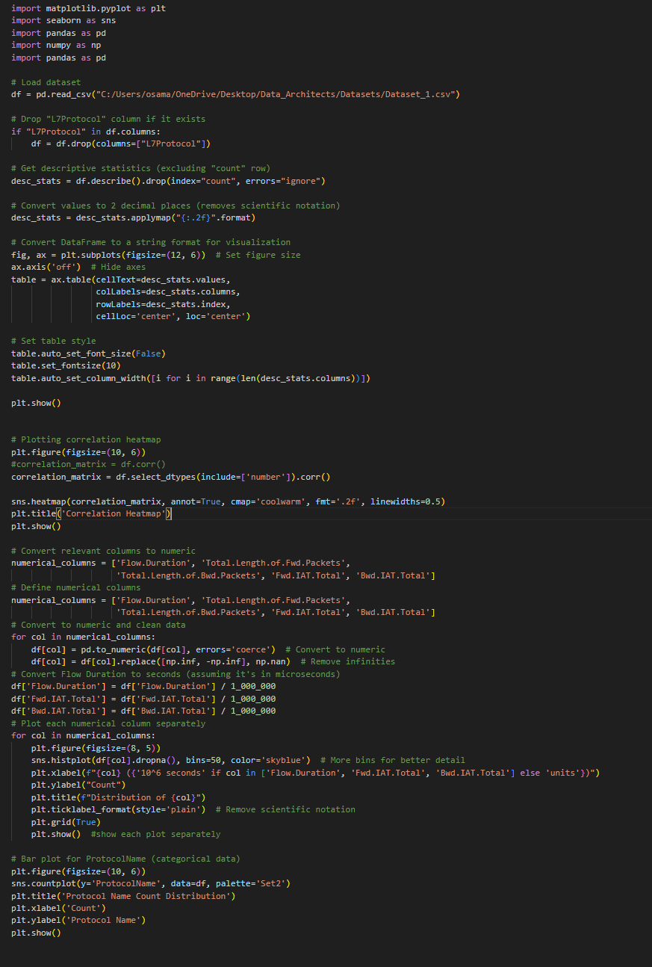

Datasets used:

<https://github.com/TarekOsama528/Data_Architects/tree/main/Datasets>